Suction Enabled Tool – Manufacturing

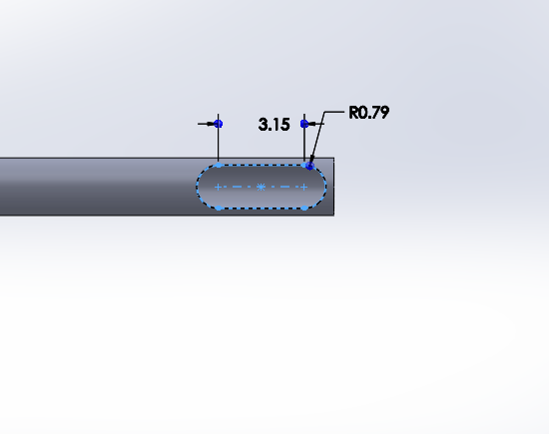

Tube: stainless steel tube, 8988K35

Tube diameter: 2.11 mm

Use 1/16” end mill – Mill X: 0-3.15mm, Z: 0-1mm